Yellowknife Music Festival

INSTRUMENTAL CLASSES

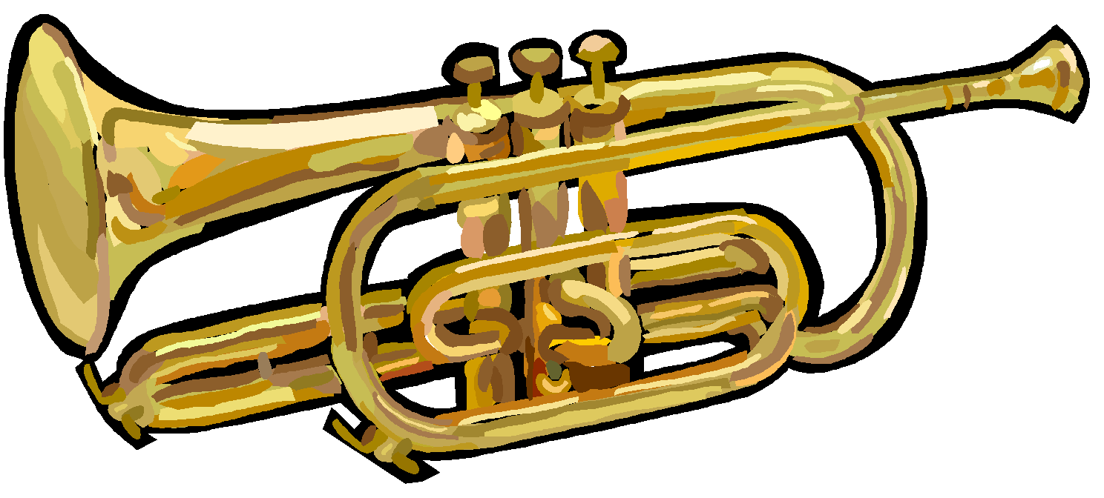

YOUTH CLASSES - 18 & under
The following classes are available at the Yellowknife Music Festival in addition to those listed in the Alberta Music Festival Association syllabus. These classes are not eligible for entrance into the Alberta Provincial Music Festival.

WOODWIND/ BRASS/ PERCUSSION SOLO - ONE selection, own choice.
3300 INSTRUMENTAL SOLO - Beginner - 1st year of study

YOUTH/ADULT CLASSES – Any age combination in one ensemble.
Please state instruments on the application form.

INSTRUMENTAL DUET: one selection, own choice, max. 10 minutes.
3340 INSTRUMENTAL DUET

Please consult the AMFA syllabus for more class options: Brass, WoodWinds, Percussion

ADULT CLASSES - 19 & older

WOODWINDS/ BRASS/ PERCUSSION/ RECORDER SOLO: One selection, own choice.
3350 INSTRUMENTAL SOLO

WOODWINDS/ BRASS/ PERCUSSION/ RECORDER CONCERT GROUP:
Perform any TWO CONTRASTING PIECES from a current conservatory syllabus.
3351 INSTRUMENTAL CONCERT GROUP

WOODWIND/BRASS/ PERCUSSION/ RECORDER DUET: One selection, own choice.
3352 INSTRUMENTAL DUET

WOODWIND/BRASS/ PERCUSSION/ RECORDER ENSEMBLE: Two selections, own choice.
3353 INSTRUMENTAL ENSEMBLE - 3+ members

Application Information

Non-Competitive Participation (NC)
Instrumentalists entering the class as non-competitive will be given a written evaluation only. Please indicate your choice by entering NC after the class number on the registration form.

Competitive Participation (C)
Instrumentalists entering the class as competitive will receive a written evaluation and a rating if they perform to the standard as set by the festival committee. Please indicate your choice by entering C after the class number on the registration form. Marks will not be disclosed to performers on the adjudication sheets. Any number of participant(s) may be given the same rating in a class provided that the adjudicator feels that the participant(s) meets the following standards:

GOLD: An outstanding performance and achieving a mark of 90+
SILVER: An excellent performance and achieving a mark of 85 - 89
BRONZE: Very good performance and achieving a mark of 80 - 84
PARTICIPANT: Good Overall. Shows accomplishment and promise

●ENTRY FEES are $30 per solo class and $50 per duet/ensemble class.
●ORIGINAL COPIES of all music must be provided for the adjudicator. Purchased computer downloads are acceptable with receipt of purchase.
●The competitor/ensemble’s name should appear on all music submitted to the adjudicator.
●Clearly mark the appropriate pages in all music that is submitted to the adjudicator.
●Competitors are required to state the number of minutes for the performance on the application form.
●Please state the name of the instrument for performance on the application form.
●COMPETITORS MUST SUPPLY ORIGINAL SCORES FOR THE ADJUDICATORS. A complete published score, including solo and accompaniment must be provided. Scores must be left with the secretary prior to the start of the class in which they are performing. Competitors should use the edition specified in the syllabus. Accompanists can use photocopies.
●The maximum time for solo selections is 10 minutes.

APPLICATION DEADLINE IS February 28. NO LATE APPLICATIONS WILL BE ACCEPTED. FEES ARE DUE AT THE TIME OF REGISTRATION.

